What’s in a Name:
Why Our Region Has So Many Names for the Plant Communities
By Susan Ballinger

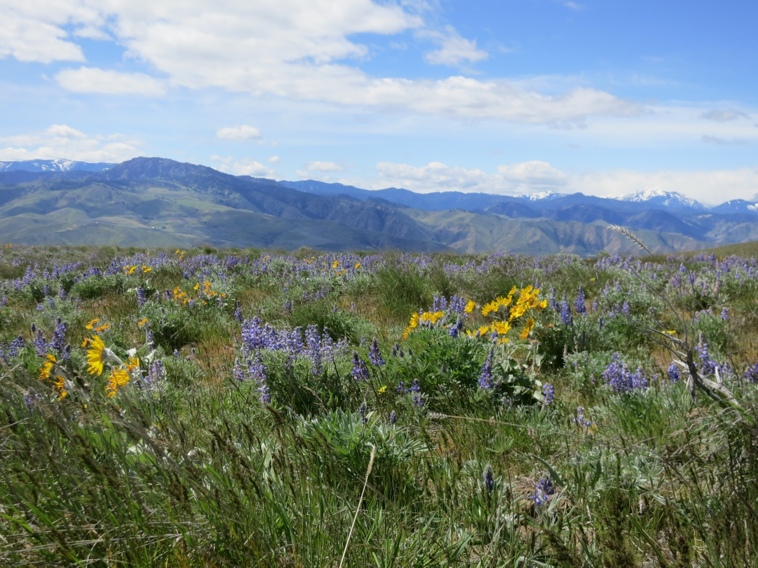Depending on who’s talking, our landscape is called by many names: the Columbia Plateau, the Columbia Basin Eco-region, Arid Lands, the Shrub-steppe Ecosystem, or simply, the sagebrush grassland. Surprising, all of these names are correct and thus reflect the complexity of life found in our part of Washington. Each name reflects a different focus of interest.

Geologists tend to use the phrase Columbia Plateau to describe the same land geographers call the Columbia Basin. Our region began to form more than 17 million years ago when floods of slow-moving liquid lava rolled across more than 63,000 square miles of Washington, Oregon, and Idaho.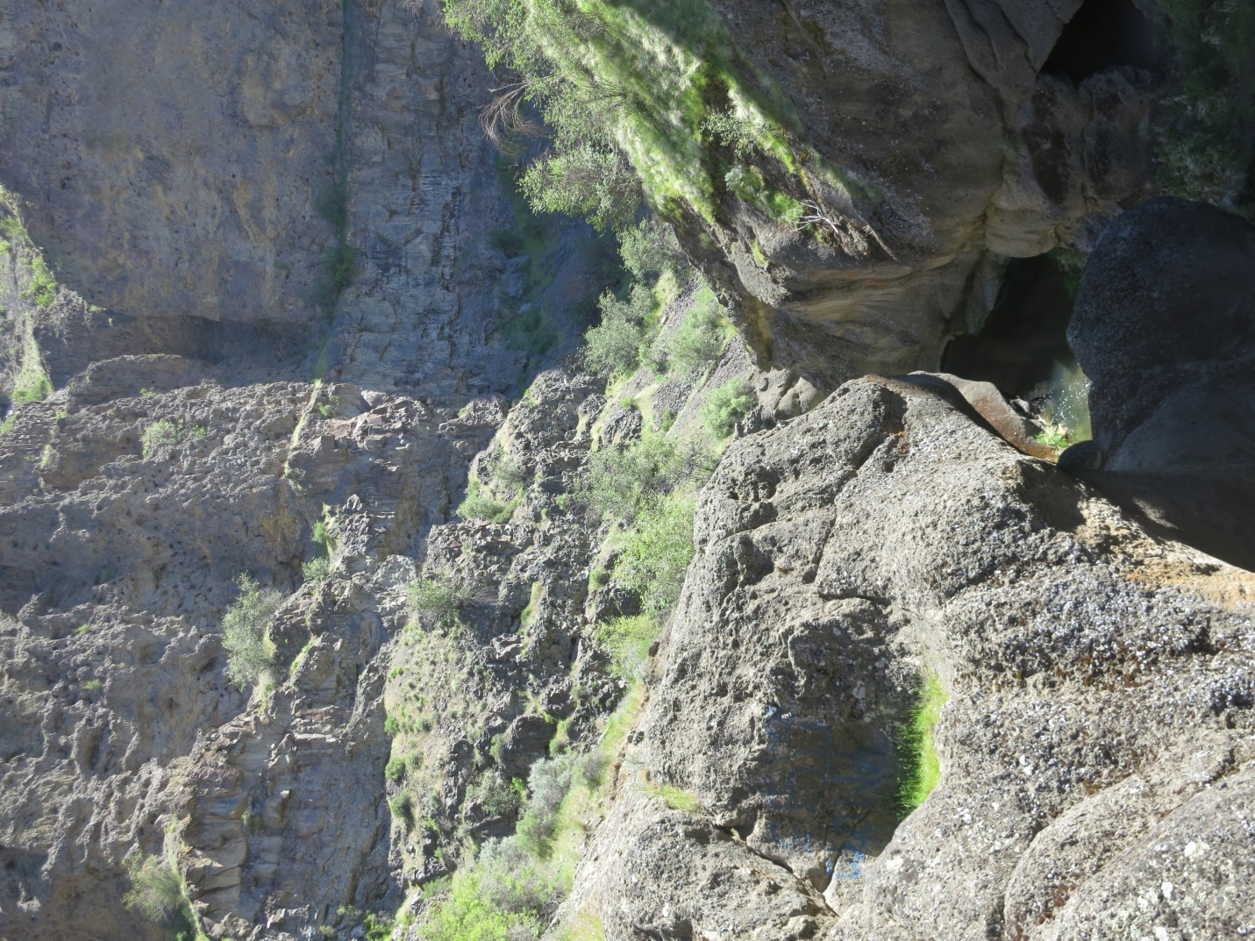 Floods of lava happened repeatedly solidifying in many layers of basalt, 1000s of feet thick. Movement of the earth’s plates later caused ridges and valleys to form, and then rivers eroded the ridges and filled the valleys with sediment. The word plateau is used to describe the “layer cake” of basalt rock, which forms the foundational bedrock of our landscape.

Looking east from Wenatchee’s Western foothills, basalt layers at the edge of Badger Mountain are exposed, at the edge of the plateau. 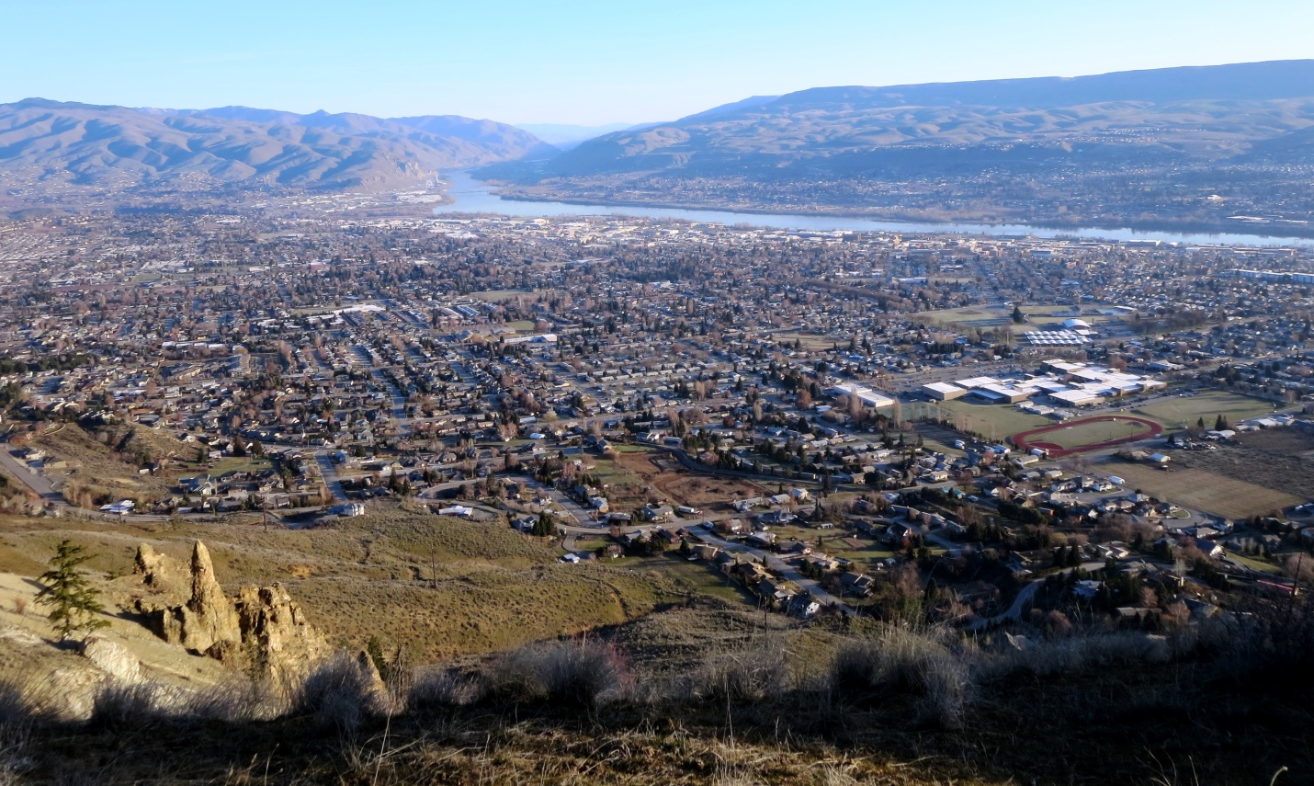

Geographers think in terms of rivers, mountains, and precipitation patterns. Geographers call us The Columbia Basin Eco-region or the Columbia Basin for short. An Eco-region is defined by the living plants and animals and by the nonliving topography, geology, climate, and soils of a region. Biologists use the slightly more general term, Ecosystem, to describe the relationships between the all of the living (biotic) and all of the non-living (abiotic) components of the environment of a particular place. The Columbia Basin comprises the complex mix of mountains, high plateaus, desert-like basins, river valleys, rolling uplands, and deep gorges woven together by the Columbia River and its tributaries. 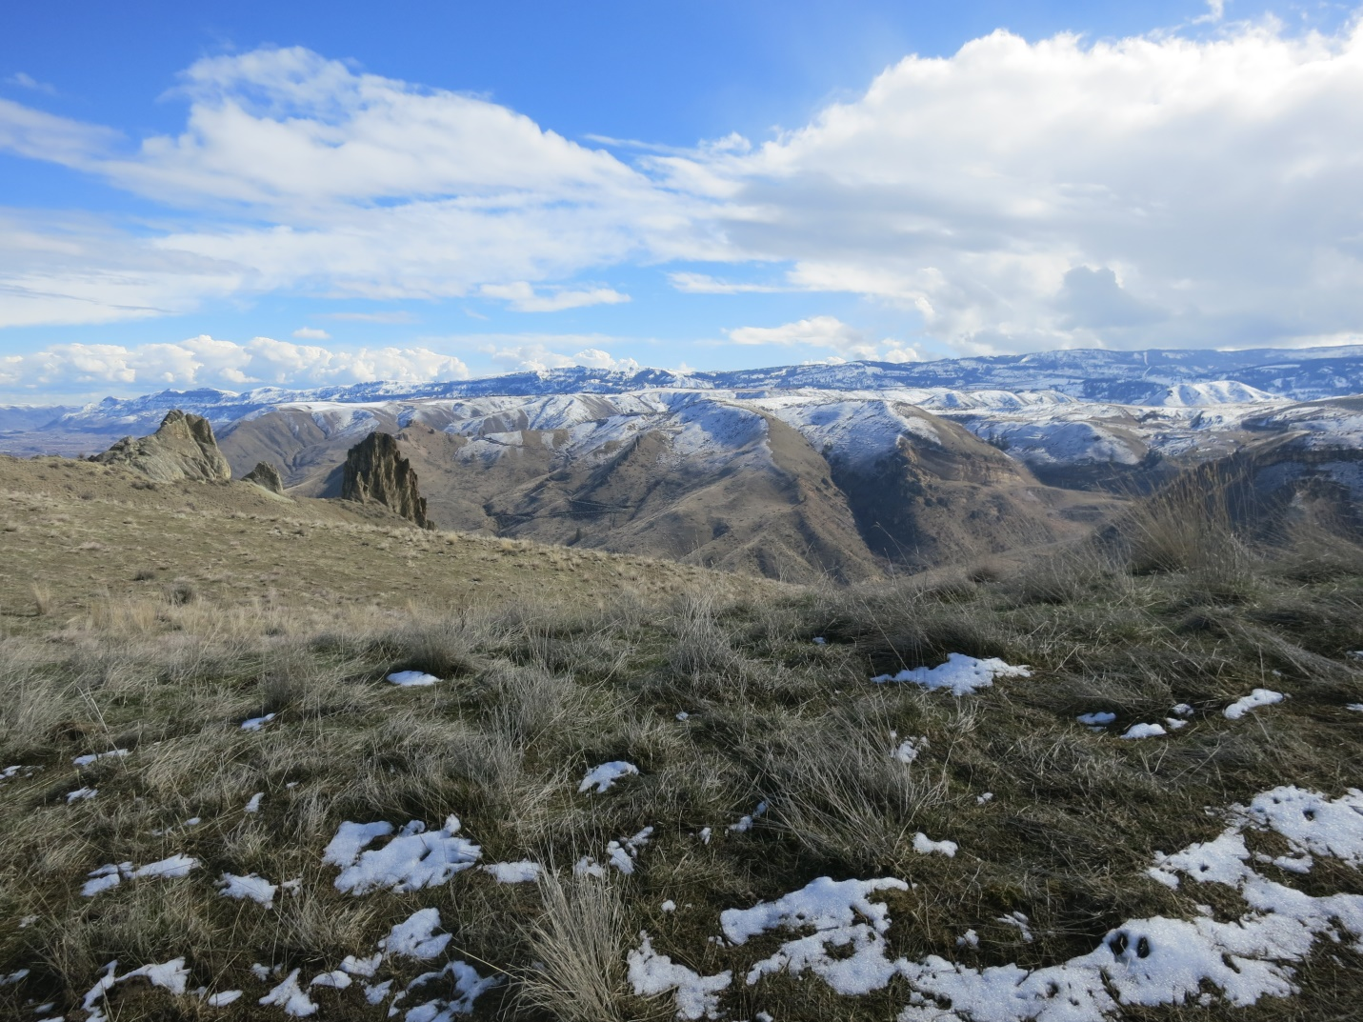The Columbia Basin is ringed by mountains with the Cascade Mountains on the west, the Rocky Mountains to the east, the Okanagan Highlands to the north, and the uplands of Oregon to the south, hence the term “basin” to describe the interior lands.

The name Arid Lands is sometimes used to describe the climate of the Columbia Basin, due to the rain-shadow effect. This rain shadow effect is due to the north-south Cascade mountain range that blocks moist winds from the Pacific Ocean. As the eastward-moving air rises from the Pacific and moves up the slopes of the Cascades, it cools and loses its ability to retain moisture. Rain and snow fall on the western side. The air warms as it descends east of the mountains and is able to hold more moisture, resulting in little precipitation. For example, annual precipitation in Wenatchee is about 9 inches, with over half of that falling as winter snow and less than one inch per month during the summer. In general, the Columbia Basin is characterized by hot, dry summers, wet and cold winters. The region experiences strong winds throughout the year. 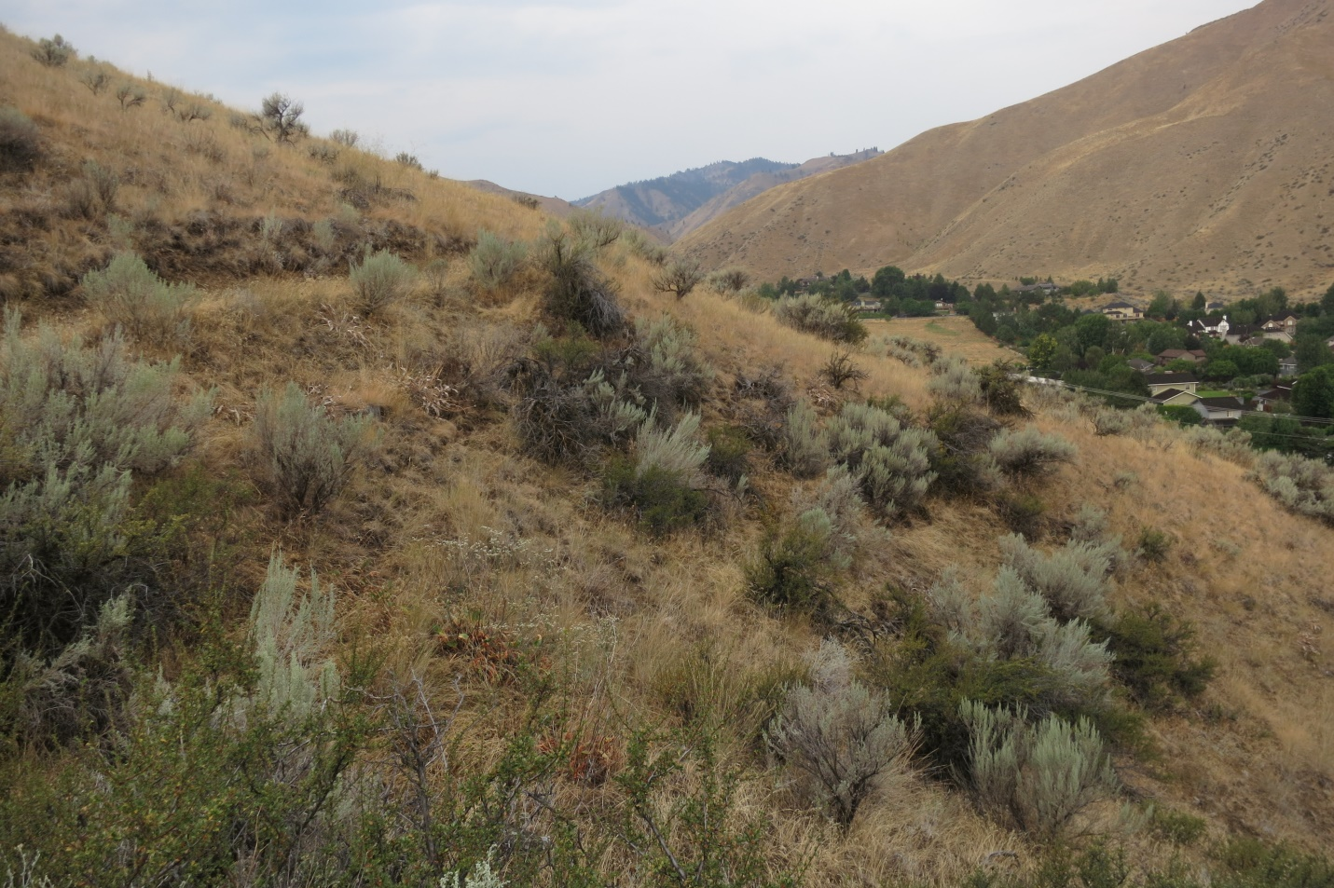

The terms Shrub-steppe Ecosystem, or more simply, sagebrush grasslands are phrases used by biologists to describe the most abundant plant communities that provide habitat to wildlife in our landscape. The plants are adapted to survive in the harsh climate of the Columbia Plateau and grow where at least one foot of wind-deposited soils are found on top of the basalt rock. 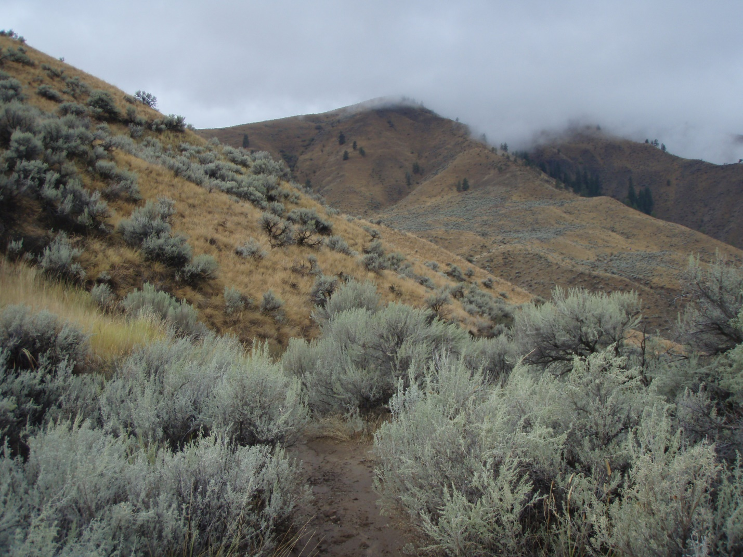Big sagebrush is the most common shrub and bunchgrasses are the main ground cover. Many wildflowers bloom from early spring until fall. The plant community, in turn, supports a complex web of life in the populations of animals who all find food, shelter, water, and a place to rear young. 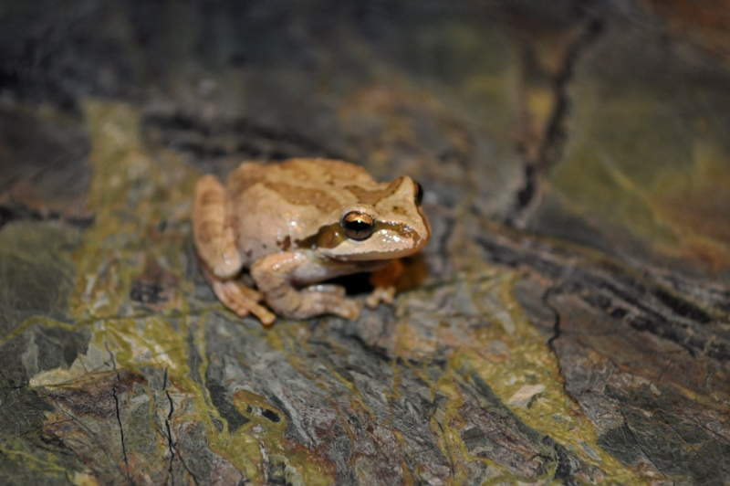

The many names of our region describe a complex and interesting eco-region, beckoning you to come explore it in all seasons. In April, soft hues of green carpet the foothills while bright spots of yellow, blue, and white blossoms pepper the landscape that surround our central Washington valleys. It is hard to find a more beautiful time of year to get out and explore the wild lands of our region, especially for wildflower enthusiasts. After five months of bitter cold and before the drying winds and sizzling heat of summer, spring is a time of moist soils and moderate temperatures. Annual precipitation within the Columbia Basin ranges from 7-11 inches. 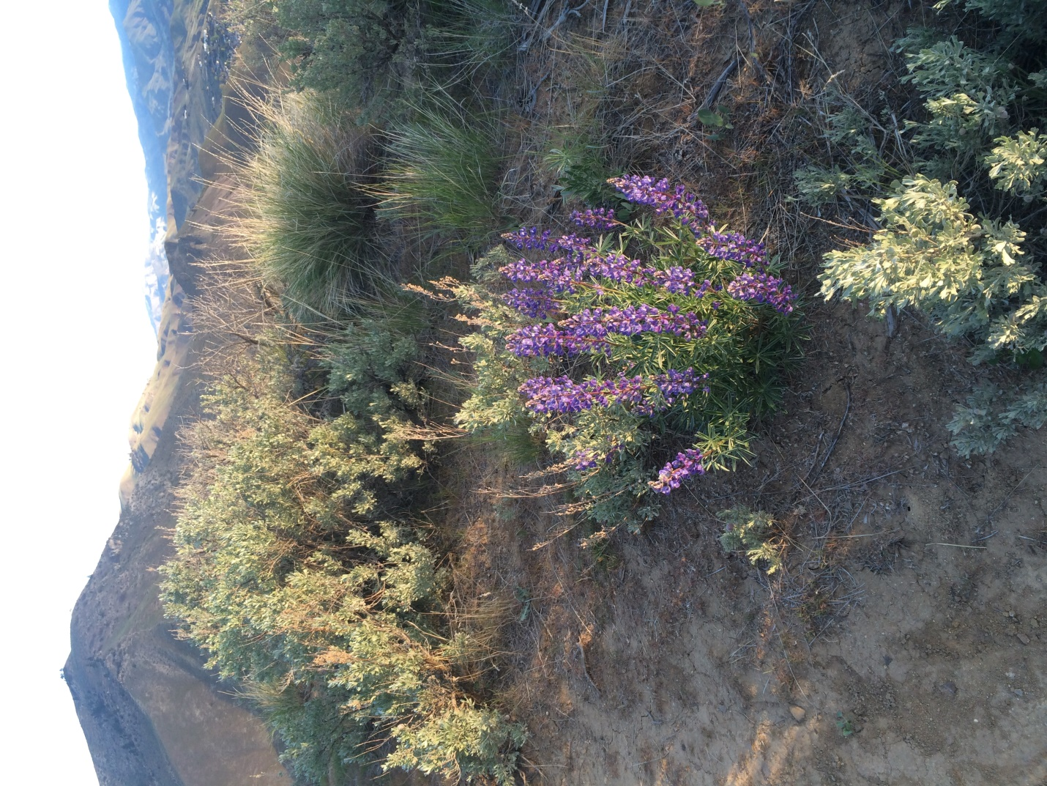With half of this annual moisture locked in ice and snow, abundant life-giving liquid water is unavailable to plants until the spring melt saturated the soil for a few brief weeks. The term shrub-steppe or sagebrush grasslands are the name for the community of plants adapted to our climate. 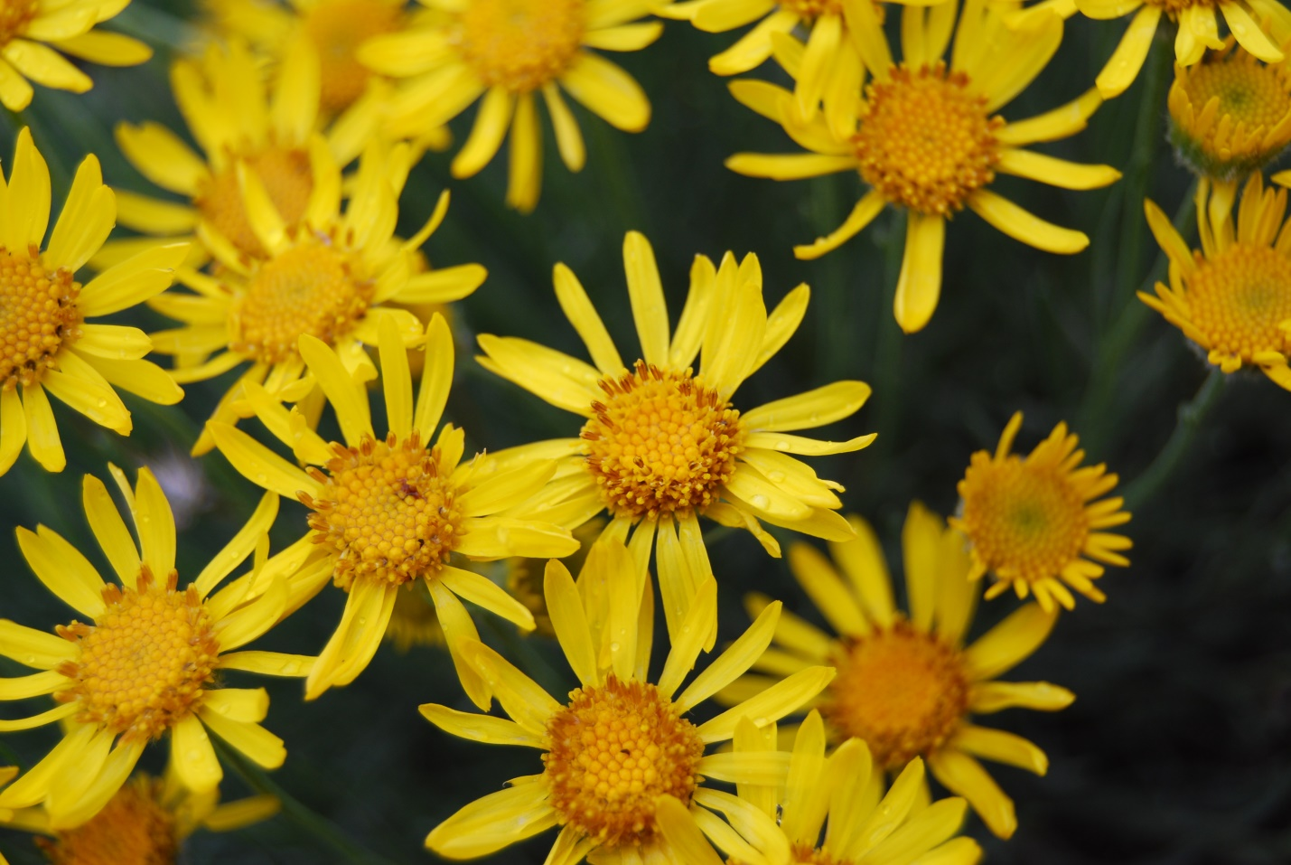 Big sagebrush and bitterbrush are the most common woody shrubs intermixed with bunchgrasses and a wide a variety of wildflowers. 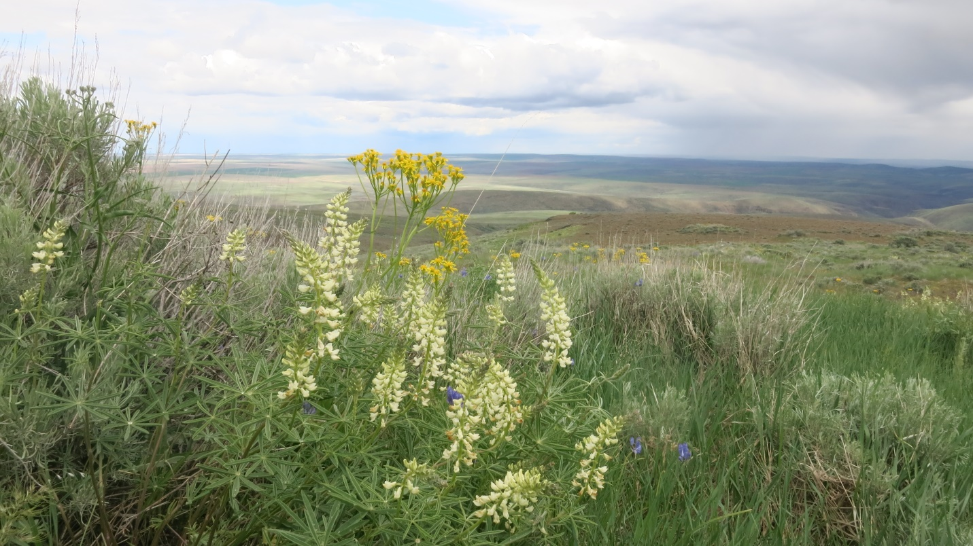

North central Washington sits on the eastern edge of the Cascade Mountains, so our foothills rise steeply into forested mountains where precipitation is greater and ponderosa pine and Douglas-fir trees grow. Valley residents can use their eyes to map the lowest elevation pine trees that form the transition zone between shrub-steppe and forest on our rising foothills. 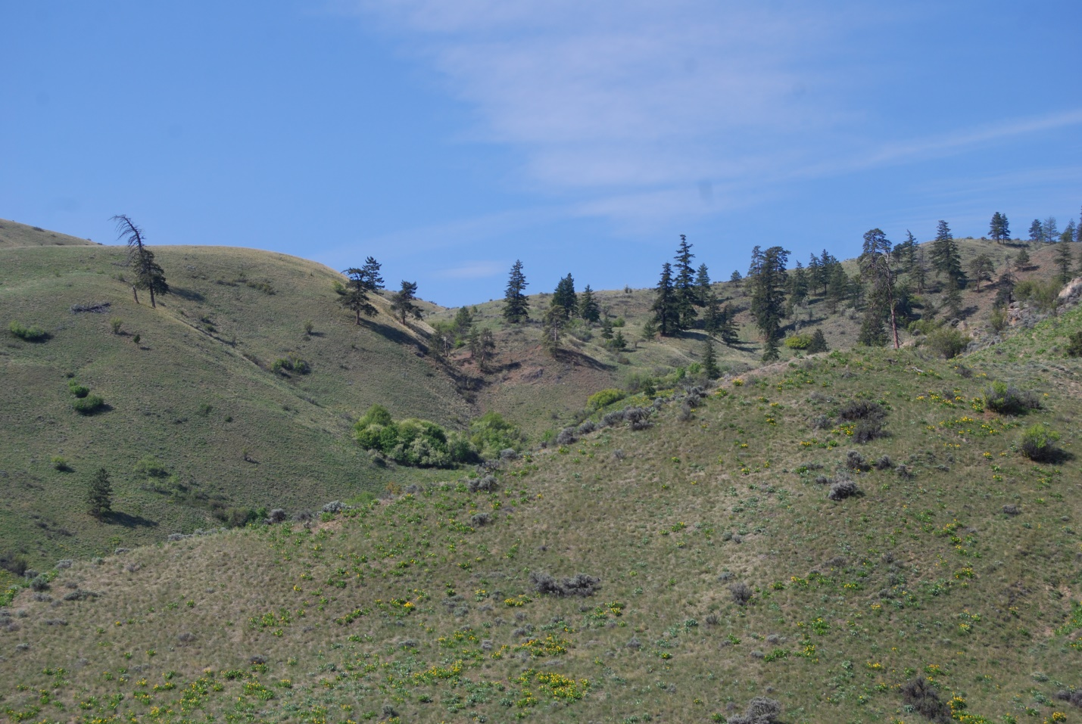Ravines and gullies serve as vertical connectors, supporting taller shrubs like serviceberry whose deep-growing roots tap into groundwater. 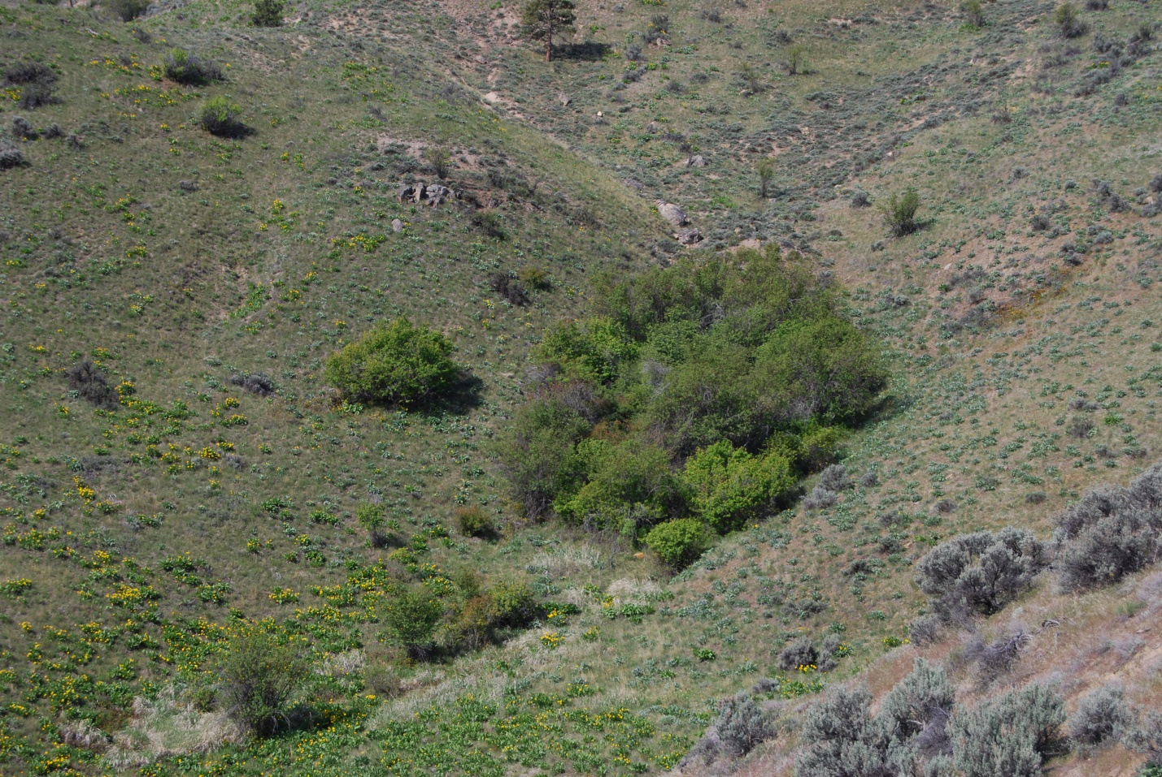As you walk or drive around the valleys, scan the hillsides to spot blooming serviceberry shrubs. Their densely blooming long-petaled white flowers create cloud-like bursts of white with a brief week-long explosion of blooms. 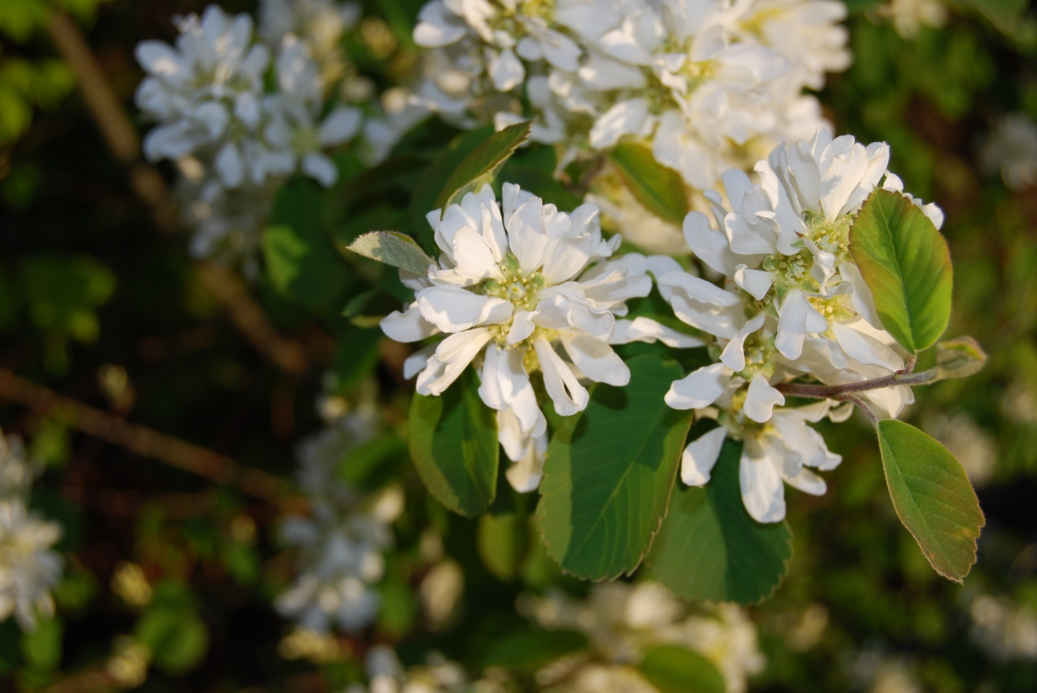As you drive the east-west corridor between Wenatchee and Leavenworth, compare the time of serviceberry flowering between the warmer and drier south-facing versus and cooler north-facing slopes. Often, wildflowers will bloom weeks sooner at the same elevation on a south-facing slope, compared to a nearby north facing slope. Another blooming gradient to follow is elevation: spring comes earlier at lower elevations, so if you miss the buttercups in March along the Columbia River, travel uphill. Time travel is possible when chasing early spring bloomers!

